**LAB 01**

**NAME:** Syed Fahad Faheem Shah

**ID:** 23k-0062

**Task #1**

**Create a new empty project**

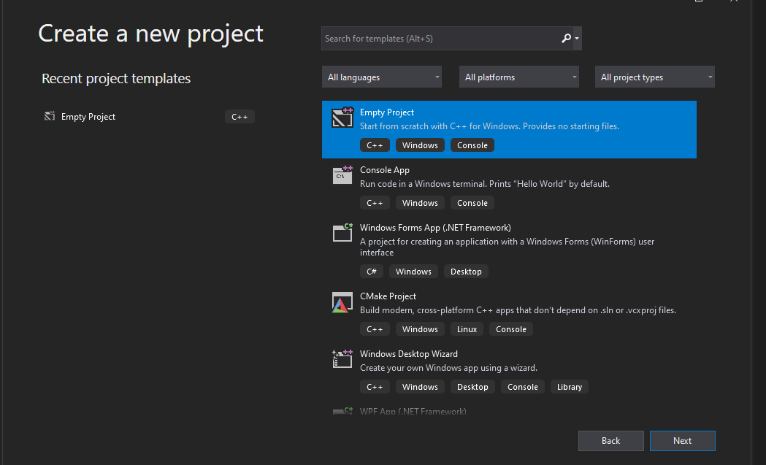

**Give a name to your project**

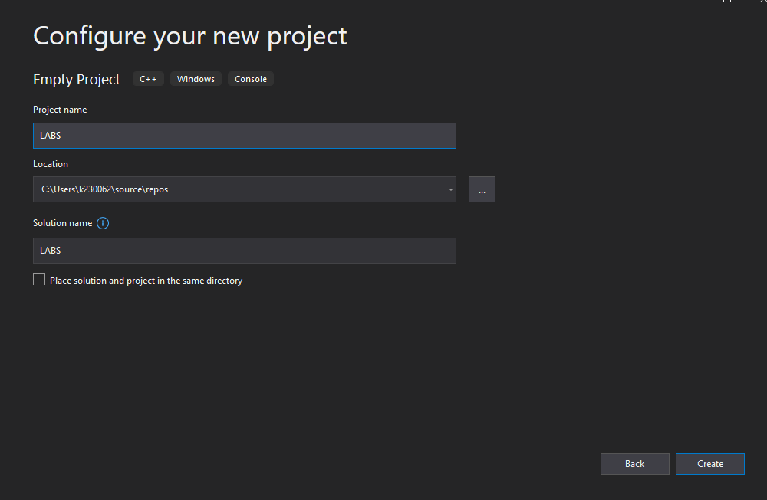

**Now right click on your project and go to Build Dependencies**

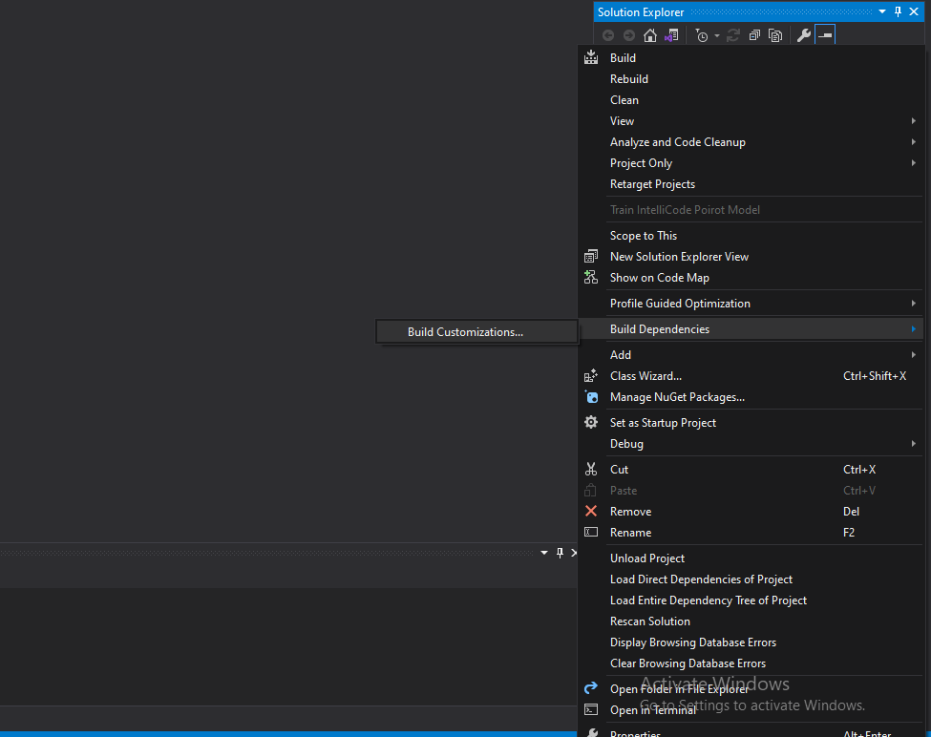

**Click on masm**

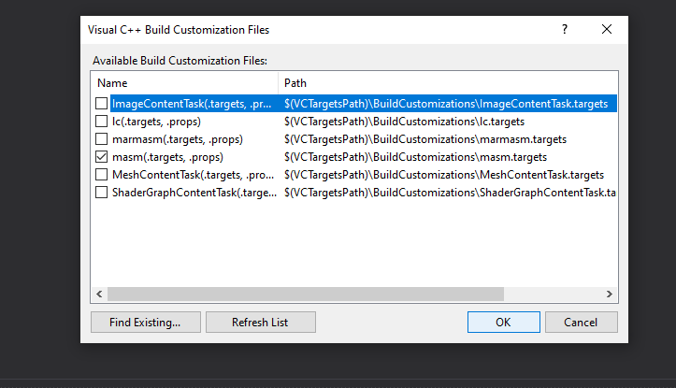

**Now again right click on your project and click on properties. After this go to General/Linker and add Irvine library path in Additional Library Directory**

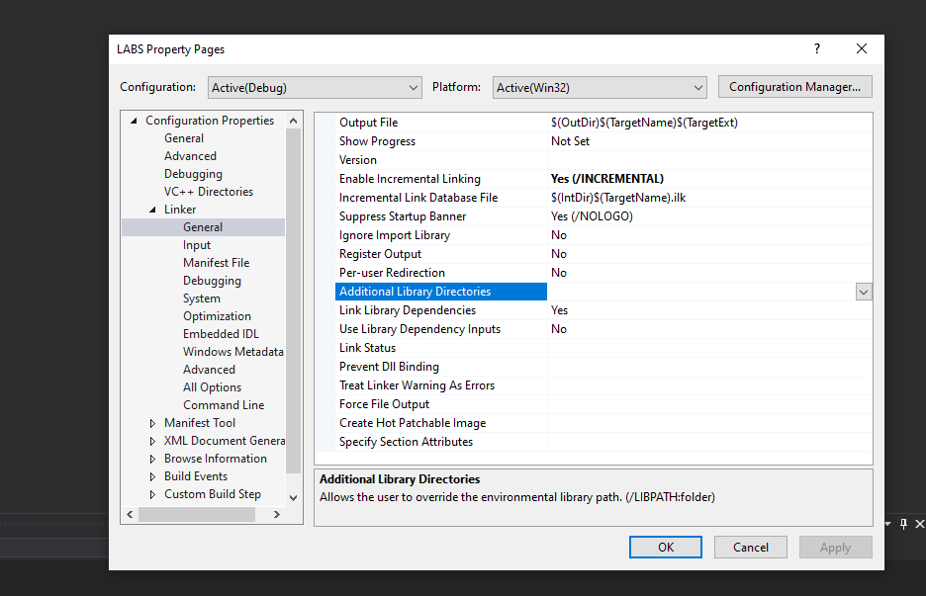

**After this go to input section and add “irvine32.lib” in Additional Dependencies**

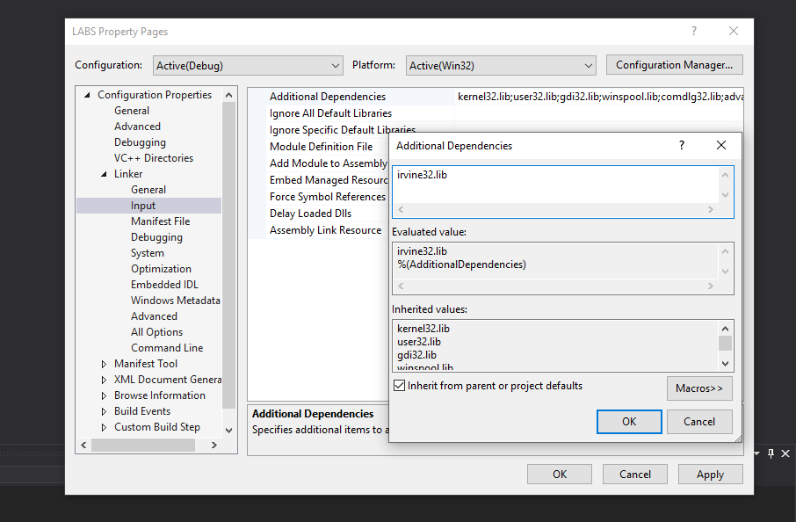

**Make a ASM file**

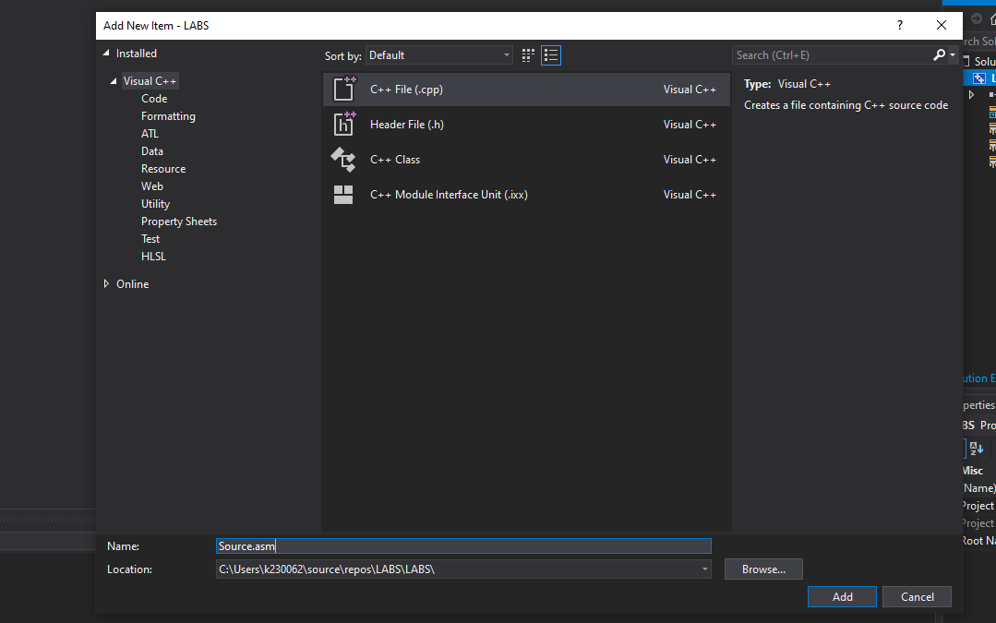

**Now again go to the properties section and if Microsoft Macro Assembly option is available that’s mean setup is done successfully. Click on this option and also add Irvine path**

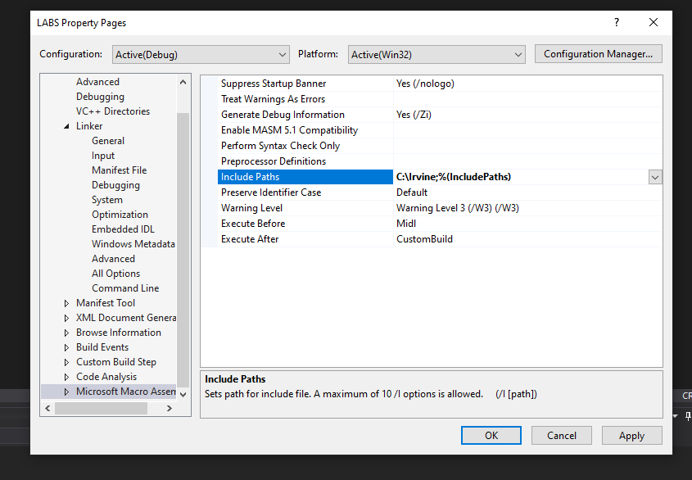

**Code:**

include irvine32.inc

.data

.code

main proc

mov eax,5

call writedec

exit

main endp

end main

**Output:**

